**CHAPTER THREE**

**METHODOLOGY**

**3.1 RESEARCH APPROACH**

The Nigerian skilled labor market faces significant structural inefficiencies that contribute to high unemployment rates among qualified tradespeople despite substantial demand for their services. Traditional job-matching mechanisms rely heavily on informal networks, word-of-mouth referrals, and chance encounters, creating substantial barriers for both skilled workers seeking employment and clients requiring quality trade services. This research addresses the critical gap between skilled labor supply and demand through the development of an AI-enhanced digital marketplace platform called SkillBridge.

The research approach for developing the AI-powered marketplace for Nigeria’s skilled workforce is a systematic and data-driven methodology that integrates artificial intelligence (AI) and machine learning (ML) techniques to address the skills mismatch and unemployment challenges in Nigeria. This study adopts a design science research (DSR) approach, which focuses on creating and evaluating an innovative artifact—in this case, an AI-powered job-matching platform.

The approach combines qualitative and quantitative methods to gather requirements, design the system, and evaluate its performance using the metrics outlined in Chapter 1 (Daily/Monthly Active Users, Job Match Success Rate, Prediction Accuracy, Fraud Detection Rate, and Identity Verification Success).

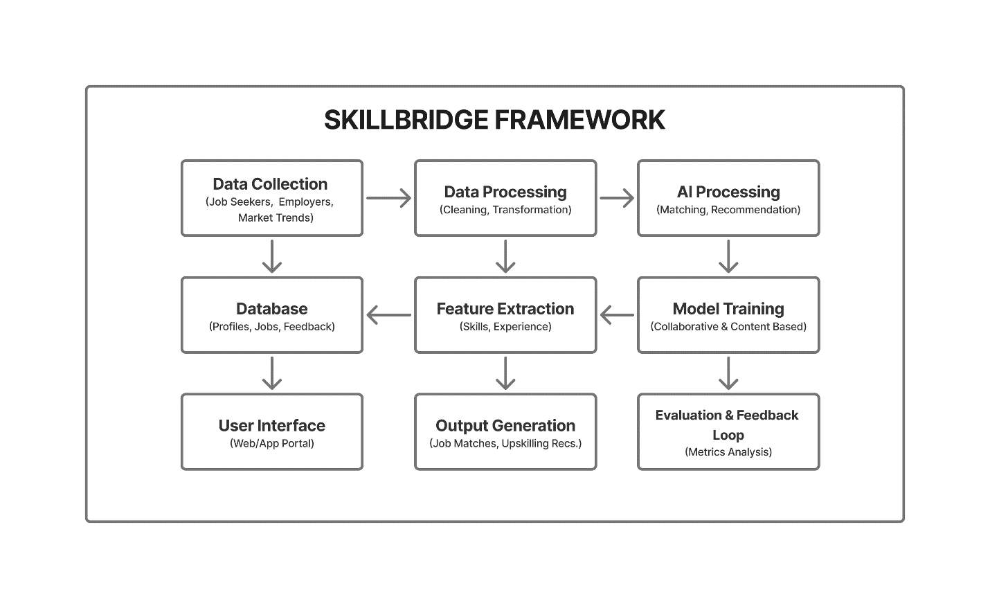  
Figure 3.1. A Block Diagram of the Skillbridge Framework

Below are the definitions and roles of each component in the block diagram:

**Data Collection:**

This is the process of gathering raw data from multiple sources, including job seeker profiles, employer job postings, and labor market trends

Role: Collects input data such as resumes, skills, certifications, job descriptions, and market reports to feed into the system. Sources include surveys, job portals (e.g., Jobberman), and industry reports.

Example: A job seeker uploads their profile (skills, experience, certifications), and an employer posts a job listing with specific requirements.

**Data Preprocessing:**

This is the cleaning, transformation, and structuring of raw data to make it suitable for AI processing.

Role: Removes inconsistencies (e.g., missing values, duplicates), normalizes data (e.g., standardizing formats), and converts unstructured data (e.g., resumes, job descriptions) into structured formats using natural language processing (NLP).

Example: Converting a resume’s text into a structured format with fields like “Skills,” “Experience,” and “Education.”

**AI Processing:**

This is the core module where AI algorithms (e.g., Google Gemini Flash 4, Grok 3, GPT-4o) analyze data to perform job matching and generate upskilling recommendations.

Role: Uses machine learning models (collaborative filtering and content-based filtering) to match job seekers with job postings and recommend training based on skills gaps.

Example: Matching a carpenter’s profile with a construction job based on skills and location.

**Feature Extraction:**

This is the process of identifying and extracting relevant attributes (features) from preprocessed data to be used by AI models.

Role: Extracts key features like skills, experience, certifications, job requirements, and location from user profiles and job postings.

Example: Extracting “Python programming” and “3 years of experience” from a job seeker’s profile.

**Model Training:**

This process of training AI models using historical and real-time data to improve prediction accuracy and recommendation quality.

Role: Trains models like collaborative filtering (based on user behavior) and content-based filtering (based on profile-job similarity) to optimize job matching and upskilling recommendations.

Example: Training a model to predict job matches based on successful hires from historical data.

**Database:**

This is a centralized storage system for managing user profiles, job postings, feedback, and market trend data.

Role: Stores structured data for quick retrieval and updates, ensuring scalability and data integrity.

Example: A MongoDB or MySQL database storing job seeker profiles, job listings, and user interaction logs.

**Output Generation:**

This is the process of producing actionable results, such as job matches, upskilling recommendations, and analytics reports.

Role: Delivers personalized job recommendations to job seekers, candidate shortlists to employers, and training suggestions based on skills gaps.

Example: Recommending a welding course to an artisan whose skills are in demand but outdated.

**User Interface (Web/App Portal):**

This is the front-end interface where users (job seekers and employers) interact with the platform.

Role: Provides a user-friendly portal for profile creation, job searching, posting jobs, and viewing recommendations. Designed with the Technology Acceptance Model (TAM) in mind to ensure ease of use and perceived usefulness.

Example: A mobile app where a job seeker updates their portfolio and receives job alerts.

**Evaluation & Feedback Loop:**

This is the process of assessing the platform’s performance using predefined metrics and incorporating user feedback to improve the system.

Role: Measures metrics like Job Match Success Rate, Prediction Accuracy, Fraud Detection Rate, and Identity Verification Success to evaluate effectiveness and refine AI models.

Example: Analyzing the percentage of successful hires to improve the matching algorithm.

**3.2 INPUT DESIGN TABLE**

The input design table outlines the data required for the platform, including their sources, formats, and purposes.

|  |  |  |  |
| --- | --- | --- | --- |
| **INPUT** | **SOURCE** | **FORMAT** | **PURPOSE** |
| Job Seeker Profile | Job Seekers via Web/App Portal | Structured (JSON, Form Data) | Provide skills, experience, certifications, and preferences for job matching |
| Job Postings | Employers (via Web/App) | Structured (JSON, Form Data) | Specify job requirements, location, salary, and other criteria |
| Market Trends | Job Portals, Industry Reports | Unstructured (Text, CSV) | Analyze labor market demands and skills gaps for recommendations |
| User Feedback | Job Seekers, Employers | Structured (Ratings, Comments) | Improve AI model accuracy and user experience |
| Identity Verification | Job Seekers, Employers | Documents (PDF, Image) | Verify authenticity of users to prevent fraud |

**3.3 OUTPUT DESIGN TABLE**

The output design describes the results generated by the platform and how they are presented to users.

|  |  |  |  |
| --- | --- | --- | --- |
| **OUTPUT** | **FORMAT** | **RECIPIENT** | **PURPOSE** |
| Job Matches | List/Table (Web/App) | Job Seekers, Employers | Display relevant job opportunities or candidate shortlists |
| Upskilling Recommendations | Text/Links (Web/App) | Job Seekers | Suggest training programs to address skills gaps |
| Analytics Reports | Charts/Graphs (Web/App) | Employers, Administrators | Provide insights into market trends and hiring patterns |
| Fraud Alerts | Notifications (Web/App, Email) | Administrators, Users | Flag suspicious activities (e.g., fake profiles, job scams) |
| Verification Status | Status Update (Web/App) | Job Seekers, Employers | Confirm successful identity verification or flag issues |

**3.4 DATA FLOW – HOW DATA MOVES THROUGH THE SYSTEM**

The data flow in the Skillbridge describes how information is collected, processed, stored, and transformed into actionable outputs (e.g., job matches, upskilling recommendations). Below is a step-by-step explanation of the data flow, referencing the DFD and aligning with your project’s objectives to address Nigeria’s skills mismatch and unemployment challenges. See Fig. 3.2 for a more diagrammatic visualization of the data flow.

**3.4.1 DATA COLLECTION (PROCESS 1):**

**Input:** Raw data from external entities:  
Job Seekers: Provide profile data (e.g., skills, experience, certifications, location) via the user interface (web/app portal).  
Employers: Submit job postings (e.g., job title, requirements, salary, location)  
External Data Sources: Supply market trends data (e.g., in-demand skills, industry reports) from job portals (e.g., Jobberman) or government agencies (e.g., National Bureau of Statistics).

**Data Flow:**Profile data flows to D1: User Profiles.  
Job posting data flows to D2: Job Postings  
Market trends data flows to D3: Market Trends.

**Purpose:** Collects diverse data to build a comprehensive dataset for AI processing. For example, a carpenter in Lagos uploads their profile with skills like “woodwork” and “furniture design,” while a construction company posts a job requiring “3+ years of carpentry experience.”

**Challenges:** As noted in your project’s limitations, data from Nigeria’s informal labor market may be incomplete or inconsistent, requiring robust validation mechanisms.

**3.4.2 DATA PREPROCESSING (PROCESS 2):**

**Input:** Raw data from D1: User Profiles, D2: Job Postings, and D3: Market Trends.

**Process:** Cleans, normalizes, and structures data for AI processing. For example:   
Removes duplicates or missing values (e.g., incomplete resumes).  
Converts unstructured text (e.g., resumes, job descriptions) into structured formats using natural language processing (NLP) techniques like tokenization or named entity recognition.  
Standardizes formats (e.g., converting “5 yrs exp” to “5 years experience”).

**Data Flow:** Preprocessed data is sent to Process 3: Extract Features and stored back in D1, D2, D3 for future use.  
Example: A job seeker’s resume text (“Experienced welder, 4 years in pipeline construction”) is parsed into structured fields: {“Skill”: “Welding,” “Experience”: “4 years,” “Industry”: “Construction”}.

**Purpose:** Ensures data is clean and consistent, enabling accurate feature extraction and AI processing.

**3.4.3 FEATURE EXTRACTION (PROCESS 3):**

**Input:** Structured data from Process 2.

**Process:** Identifies and extracts relevant features (e.g., skills, experience, certifications, job requirements, location) using NLP and machine learning techniques. For instance, a sentence transformer model (e.g., RoBERTa, as mentioned in Aleisa et al., 2023) may encode job descriptions and profiles into vectors for similarity analysis.

**Data Flow:** Extracted features are sent to Process 4: Process AI Matching & Recommendations.  
Example: From a job posting requiring “Python, 3+ years experience,” features like {“Skill”: “Python,” “Experience”: “3 years”} are extracted and matched with a job seeker’s profile.

**Purpose:** Prepares data for AI-driven matching by focusing on key attributes, reducing noise, and improving model efficiency.

**3.4.4 PROCESS AI MATCHING & RECOMMENDATIONS (PROCESS 4):**

**Input:** Features from Process 3 and updated AI models from Process 5.

**Process:** Uses AI models (e.g., Google Gemini Flash 4, Grok 3, GPT-4o) to:  
Perform job matching using collaborative filtering (based on user behavior patterns) and content-based filtering (based on profile-job similarity).  
Generate upskilling recommendations by analyzing skills gaps against market trends (e.g., recommending a “Data Analysis” course for a job seeker with basic IT skills).  
Implement fraud detection using anomaly detection algorithms to flag suspicious profiles or job postings.  
Verify identities using document analysis or integration with Nigeria’s National Identification Number (NIN) system.

**Data Flow:** Matches and recommendations are sent to Process 6: Generate Outputs, while processed data is stored in D1, D2, D3 for model training.  
Example: A job seeker with carpentry skills is matched with a Lagos-based construction job, and the system recommends a “Modern Furniture Design” course based on market demand.

**Purpose:** Delivers personalized, accurate job matches and training suggestions, addressing the skills mismatch and improving employability.

**3.4.5 TRAIN AI MODELS (PROCESS 5):**

**Input:** Historical and real-time data from D1: User Profiles, D2: Job Postings, D3: Market Trends, and D4: Feedback & Analytics.

**Process:** Trains and updates AI models using supervised and unsupervised learning techniques (e.g., decision table/naïve Bayes hybrid classifier, as in Papparizos et al., 2022). Models are fine-tuned to improve prediction accuracy and adapt to Nigeria’s labor market trends.

**Data Flow:** Updated models are sent to Process 4 for use in matching and recommendations.  
Example: Training a model on successful job matches to prioritize features like “industry experience” over “location” for certain roles.

**Purpose:** Ensures the AI models remain accurate and relevant by learning from new data and user interactions.

**3.4.6 GENERATE OUTPUTS (PROCESS 6):**

**Input:** Matches and recommendations from Process 4.

**Process:** Formats outputs for display via the user interface (web/app portal). Outputs include:  
Job matches (e.g., a list of relevant jobs with confidence scores).  
Upskilling recommendations (e.g., links to training programs).  
Analytics reports for employers (e.g., hiring trends).  
Fraud alerts and verification statuses.

**Data Flow:** Outputs are sent to Job Seekers and Employers via the user interface.  
Example: A job seeker receives a notification: “Match: Construction Worker, Lagos, 95% compatibility” with a link to apply.

**Purpose:** Provides actionable results to users, enhancing their job search or hiring experience.

**3.4.7 EVALUATE & REFINE (PROCESS 7):**

**Input:** Feedback from Job Seekers and Employers (e.g., ratings, comments on matches) and performance metrics (e.g., Job Match Success Rate, Prediction Accuracy).

**Process:** Analyzes metrics like Daily/Monthly Active Users (DAU/MAU), Job Match Success Rate, Prediction Accuracy, Fraud Detection Rate, and Identity Verification Success to assess system performance. Uses feedback to identify areas for improvement.

**Data Flow:** Performance metrics and refinement data are stored in D4: Feedback & Analytics and used to update Process 5: Train AI Models.  
Example: If the Job Match Success Rate is low (e.g., 50%), the system adjusts the AI model to prioritize different features (e.g., skills over location).

**Purpose:** Ensures continuous improvement of the platform, aligning with the Technology Acceptance Model (TAM) for user satisfaction and adoption.

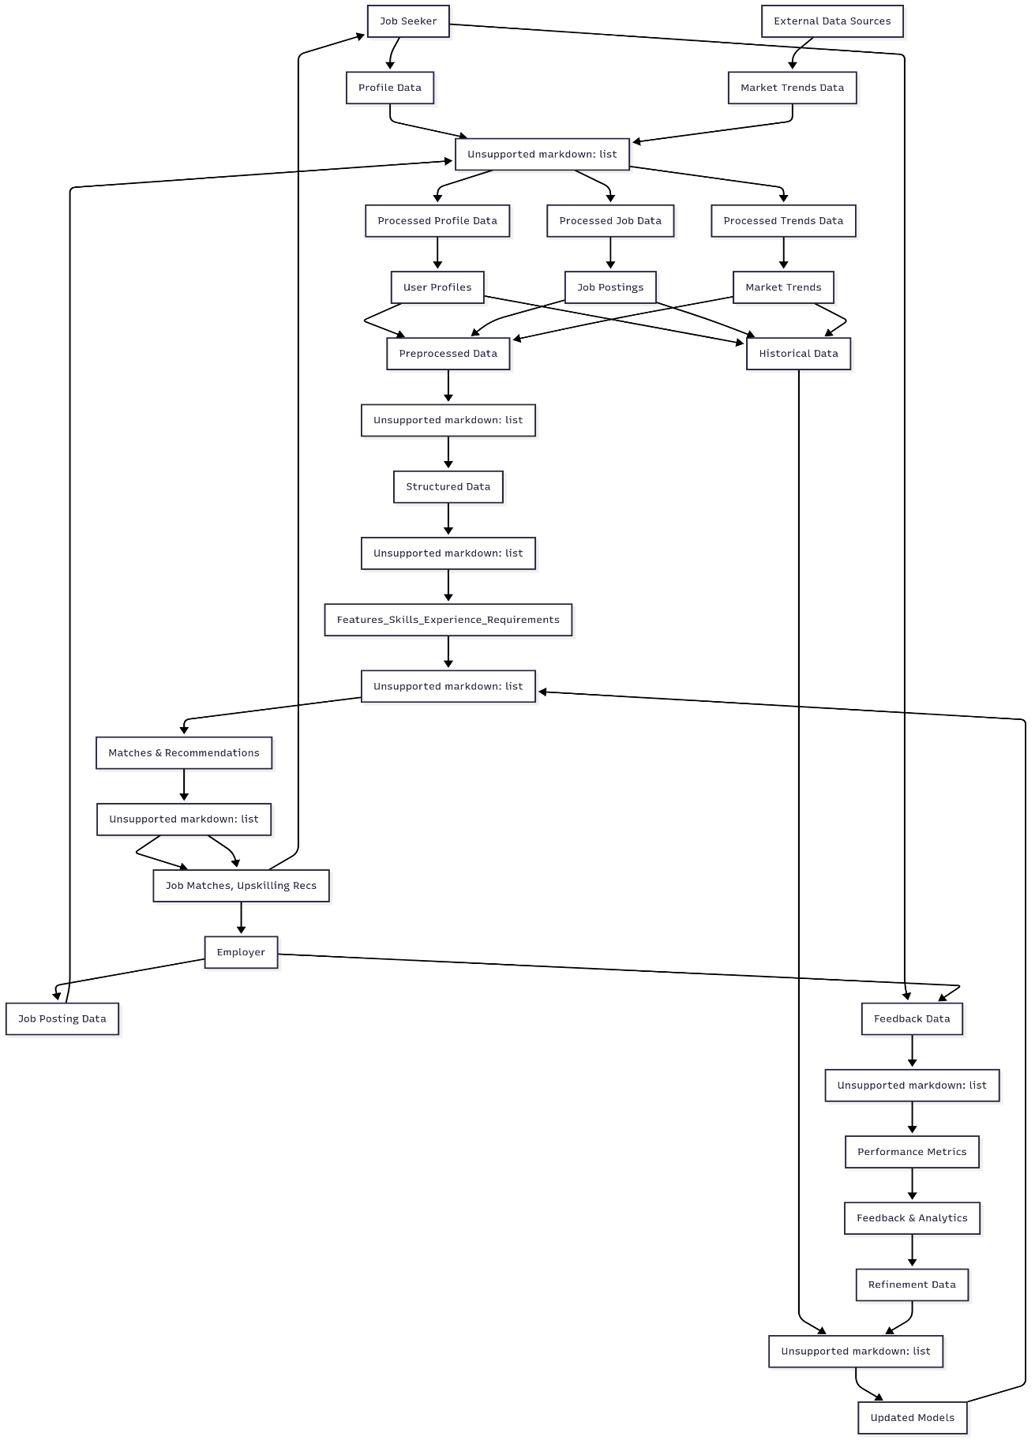

Fig. 3.2 Data Flow Diagram for Skillbridge

**3.5 USER FLOW**

The user flow describes the sequence of interactions that Job Seekers and Employers undertake when using the AI-powered marketplace. It aligns with the Technology Acceptance Model (TAM) by ensuring the platform is user-friendly (perceived ease of use) and effective (perceived usefulness). Below is a step-by-step explanation of the user flow for both user types, referencing the diagram and tying it to your project’s objectives of addressing Nigeria’s skills mismatch and unemployment. See Fig. 3.3 for a more diagrammatic visualization of the user flow.

**3.5.1 USER TYPE SELECTION**

**Action:** Users access the platform (via web or mobile app) and select their role: Job Seeker (e.g., artisans, skilled workers) or Employer (e.g., businesses, contractors).

**Purpose:** Directs users to the appropriate path based on their goals (finding a job vs. hiring a candidate).  
Example: A carpenter selects “Job Seeker,” while a construction company selects “Employer.”

**Relevance:** This decision point ensures a tailored experience, supporting the platform’s goal of connecting Nigeria’s skilled workforce with relevant opportunities.

**3.5.2 REGISTER/LOGIN**

**Action (Job Seeker):** Job seekers register by creating an account (e.g., with email, phone number) or log in if they already have an account.

**Action (Employer):** Employers register by providing business details (e.g., company name, tax ID) or log in.

**Purpose:** Authenticates users and provides access to the platform’s features. Registration ensures data collection for personalization.  
Example: A job seeker registers with their email and phone number, while an employer logs in using their business credentials.

**Relevance:** Secure authentication aligns with the Identity Verification Success metric, reducing fraud risks in Nigeria’s informal labor market.

**3.5.3 Create/Update Profile (Job Seeker) or Job Posting (Employer)**

**Action (Job Seeker):** Job seekers create or update their profile, including skills (e.g., welding, carpentry), experience (e.g., years worked), certifications, and preferences (e.g., location, salary expectations).

**Action (Employer):** Employers create or update job postings, specifying job title, requirements (e.g., “3+ years welding experience”), location, salary, and other criteria.

**Purpose:** Collects critical data for AI-driven matching. Profiles and postings are the primary inputs for the system, as described in the DFD.  
Example: A job seeker uploads a resume with “5 years carpentry experience” and a welding certificate. An employer posts a job for a “Lagos-based carpenter, ₦150,000/month.”

**Relevance:** Profiles enhance visibility for skilled workers, addressing the problem of poor connection to formal employment networks. Job postings enable precise matching, reducing skills mismatches.

**3.5.4 VERIFY IDENTITY**

**Action (Job Seeker):** Job seekers submit identity documents (e.g., National Identification Number (NIN), driver’s license) for verification.

**Action (Employer):** Employers submit business documents (e.g., CAC registration, tax ID) to verify their legitimacy.

**Purpose:** Ensures platform security and trust by confirming user authenticity, aligning with the Fraud Detection Rate and Identity Verification Success metrics.  
Example: A job seeker uploads their NIN, which is verified via an API integration with Nigeria’s identity database. An employer submits their business registration certificate.

**Relevance:** Critical for Nigeria’s context, where informal employment structures increase the risk of fraudulent profiles or job scams.

**3.5.5 SEARCH JOBS (JOB SEEKER) OR SEARCH CANDIDATES (EMPLOYER)**

**Action (Job Seeker):** Job seekers search for jobs using filters like skills, location, or salary. The system provides AI-generated job matches based on their profile.

**Action (Employer):** Employers search for candidates using filters like skills, experience, or location. The system provides AI-generated candidate shortlists.

**Purpose:** Enables users to explore opportunities or talent proactively while leveraging AI for personalized recommendations.  
Example: A job seeker filters for “carpentry jobs in Lagos” and receives matches like “Construction Worker, 95% compatibility.” An employer filters for “welders with 3+ years experience” and receives a shortlist of candidates.

**Relevance:** Supports real-time job matching, addressing the fragmented job-search process and improving efficiency in Nigeria’s labor market.

**3.5.6 RECEIVE JOB MATCHES (JOB SEEKER) OR CANDIDATE MATCHES (EMPLOYER)**

**Action (Job Seeker):** Job seekers receive AI-generated job matches tailored to their skills, experience, and preferences, displayed via the user interface.

**Action (Employer):** Employers receive AI-generated candidate shortlists, ranked by compatibility with job requirements.

**Purpose:** Delivers personalized, data-driven results, aligning with the Job Match Success Rate and Prediction Accuracy metrics.  
Example: A job seeker sees a notification: “Match: Furniture Maker, Lagos, ₦120,000/month.” An employer sees a list of candidates with skills matching their job posting.

**Relevance:** Reduces labor market frictions by providing accurate matches, addressing the mismatch between skills and opportunities.

**3.5.7. APPLY FOR JOB (JOB SEEKER) OR REVIEW & CONTACT CANDIDATES (EMPLOYER)**

**Action (Job Seeker):** Job seekers apply for matched jobs by submitting applications through the platform.

**Action (Employer):** Employers review candidate profiles, contact shortlisted candidates (e.g., via chat or email), and proceed to interviews or hiring.

**Purpose:** Facilitates the hiring process, enabling job seekers to connect with employers and employers to select qualified candidates.  
Example: A job seeker applies for a construction job by uploading a cover letter. An employer contacts a welder for an interview via the platform’s messaging feature.

**Relevance:** Streamlines the job application and hiring process, supporting the platform’s goal of reducing unemployment.

**3.5.8. RECEIVE UPSKILLING RECOMMENDATIONS (JOB SEEKER)**

**Action:** Job seekers receive personalized training recommendations based on skills gaps and market trends (e.g., courses, certifications).

**Purpose:** Enhances employability by addressing skills deficiencies, aligning with Human Capital Theory and the platform’s objective to provide upskilling suggestions.  
Example: A carpenter receives a recommendation: “Enroll in Modern Furniture Design Course to meet market demand.”

**Relevance:** Addresses Nigeria’s skills gap by helping workers align their skills with employer needs, improving economic outcomes.

**3.5.9. PROVIDE FEEDBACK (JOB SEEKER) OR POST FEEDBACK (EMPLOYER)**

**Action (Job Seeker):** Job seekers provide feedback on job matches, platform usability, or application outcomes (e.g., ratings, comments).

**Action (Employer):** Employers provide feedback on candidate quality, match accuracy, or hiring outcomes.

**Purpose:** Collects data to refine AI models and improve user experience, supporting the Evaluation & Feedback Loop and metrics like Daily/Monthly Active Users.  
Example: A job seeker rates a job match as “90% relevant.” An employer comments, “Candidate skills matched job requirements perfectly.”

**Relevance:** Ensures continuous improvement, aligning with Data-Driven Decision-Making principles and addressing user adoption challenges.

**3.5.10. RECEIVE ANALYTICS (EMPLOYER)**

**Action:** Employers receive analytics reports (e.g., hiring trends, candidate demographics, market insights) to inform recruitment strategies.

**Purpose:** Provides data-driven insights to optimize hiring, aligning with the platform’s scalability and market trend analysis features.  
Example: An employer receives a report showing “High demand for welders in Lagos, average hiring time: 10 days.”

**Relevance:** Helps employers make informed decisions, supporting economic growth by aligning hiring with market needs.

**3.5.11. END/REPEAT**

**Action:** Users either complete their goal (e.g., secure a job, hire a candidate) or repeat the process (e.g., search for more jobs, post new openings).

**Purpose:** Allows continuous engagement with the platform, ensuring long-term usability and scalability.  
Example: A job seeker who secures a job may return to update their profile or seek new opportunities. An employer may post another job after a successful hire.

**Relevance:** Supports the platform’s goal of sustained user engagement, measured by Daily/Monthly Active Users.

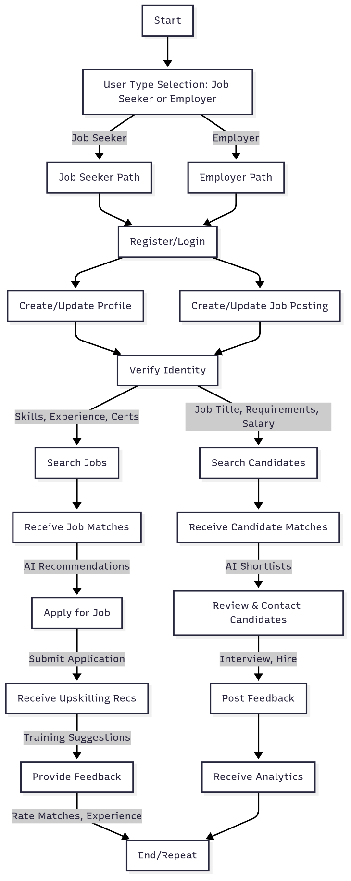

Fig. 3.3 Skillbridge User Flow.